Chapter 9
Exercises
9.3 (Using Composition Rather Than Inheritance)
Many programs written with inheritance could be written with composition instead, and vice versa. Rewrite class BasePlusCommissionEmployee (Fig. 9.11) of the CommissionEmployee–BasePlusCommissionEmployee hierarchy to use composition rather than inheritance.
9.4 (Software Reuse)
Discuss the ways in which inheritance promotes software reuse, saves time during program development and helps prevent errors.
Benefit | Explanation
Code Reuse | Write common code once in a superclass; all subclasses inherit it. No copying/pasting.
Faster Development | Build new classes by extending existing ones instead of starting from scratch.
Consistency | All subclasses share the same attributes/methods from the superclass — fewer bugs from inconsistent implementations.
Easier Maintenance | Fix or update code once in the superclass; all subclasses get the change automatically.
Polymorphism | Treat different related objects uniformly — simplifies code and reduces errors.

9.5 (Student Inheritance Hierarchy)
Draw an inheritance hierarchy for students at a university similar to the hierarchy shown in Fig. 9.2.
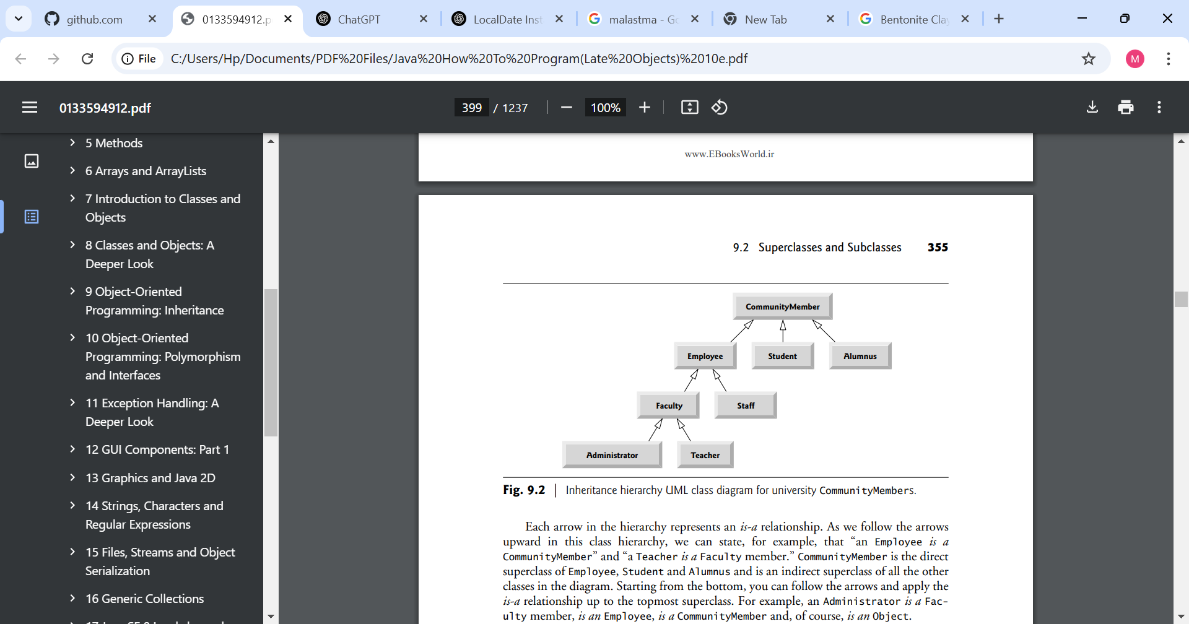Use Student as the superclass of the hierarchy, then extend Student with classes UndergraduateStudent and GraduateStudent. Continue to extend the hierarchy as deep (i.e., as many levels) as possible. For example, Freshman, Sophomore, Junior and Senior might extend UndergraduateStudent, and DoctoralStudent and MastersStudent might be subclasses of GraduateStudent. After drawing the hierarchy, discuss the relationships that exist between the classes. [Note: You do not need to write any code for this exercise.]
Student
/ \
UndergraduateStudent GraduateStudent
/ \ / \
Freshman Sophomore MastersStudent DoctoralStudent
| | | |
Junior Senior ThesisStudent ResearchStudent
9.6 (Shape Inheritance Hierarchy)
The world of shapes is much richer than the shapes included in the inheritance hierarchy of Fig. 9.3.
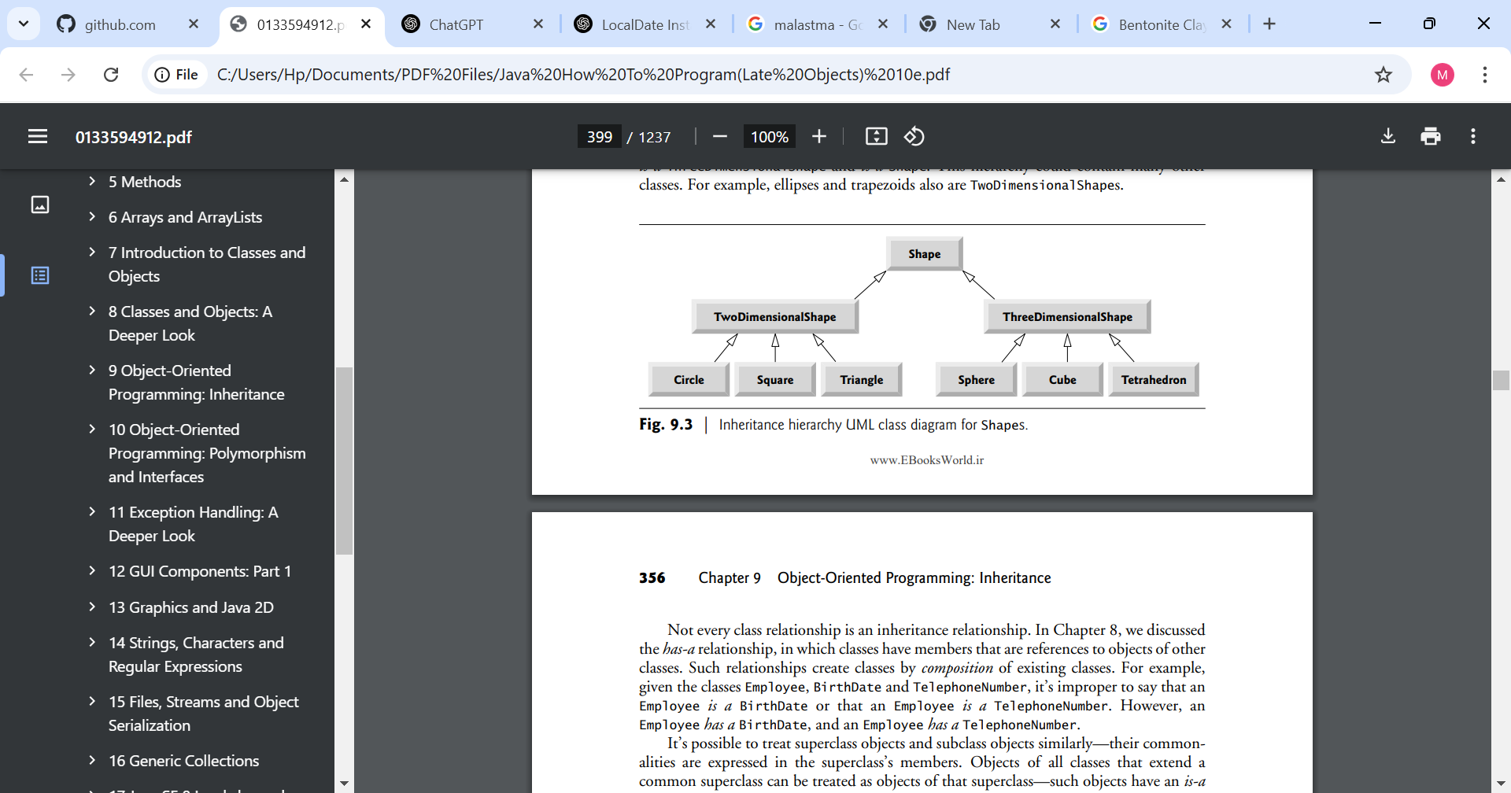
Write down all the shapes you can think of—both two-dimensional and three-dimensional—and form them into a more complete Shape hierarchy with as many levels as possible. Your hierarchy should have class Shape at the top. Classes TwoDimensionalShape and ThreeDimensionalShape should extend Shape. Add additional subclasses, such as Quadrilateral and Sphere, at their correct locations in the hierarchy as necessary.
Shape
/ \
TwoDimensionalShape ThreeDimensionalShape
/ \ / | \
Polygon Ellipse Sphere Cone Cylinder
/ \ | |
Quadrilateral Circle RectangularPrism
/ | \
Parallelogram Trapezoid
/ \
Rectangle Rhombus
|
Square
9.7 (protected vs. private)
Some programmers prefer not to use protected access, because they believe it breaks the encapsulation of the superclass. Discuss the relative merits of using protected access vs. using private access in superclasses.
private | Protected
Only accessible inside the same class | Accessible in subclasses and same package
Strongest encapsulation — subclasses cannot break internal logic | More convenient — subclasses don’t need to call getters/setters
Changes to superclass never break subclasses | Changes to superclass fields can break subclasses
Recommended for most cases | Use only when subclasses truly need direct access

9.8 (Quadrilateral Inheritance Hierarchy)
Write an inheritance hierarchy for classes Quadrilateral, Trapezoid, Parallelogram, Rectangle and Square. Use Quadrilateral as the superclass of the hierarchy. Create and use a Point class to represent the points in each shape. Make the hierarchy as deep (i.e., as many levels) as possible. Specify the instance variables and methods for each class. The private instance variables of Quadrilateral should be the x-y coordinate pairs for the four endpoints of the Quadrilateral. Write a program that instantiates objects of your classes and outputs each object’s area (except Quadrilateral).
9.9 (What Does Each Code Snippet Do?)
a) Assume that the following method call is located in an overridden earnings method in a subclass:
super.earnings()
a) super.earnings() — Calls the superclass version of the earnings() method from within the subclass’s overridden method.
b) Assume that the following line of code appears before a method declaration:
@Override
b) @Override — Annotation that tells the compiler: "I intend to override a superclass method". Catches typos/signature errors at compile time.
c) Assume that the following line of code appears as the first statement in a constructor’s body:
super(firstArgument, secondArgument);
c) super(a, b) — Calls the superclass constructor with arguments a and b; must be the first line in a subclass constructor.
9.10 (Write a Line of Code)
Write a line of code that performs each of the following tasks:
a) Specify that class PieceWorker inherits from class Employee.
public class PieceWorker extends Employee
b) Call superclass Employee’s toString method from subclass PieceWorker’s toString method.
return super.toString();
c) Call superclass Employee’s constructor from subclass PieceWorker’s constructor—assume that the superclass constructor receives three Strings representing the first name, last name and social security number.
super(firstName, lastName, ssn);

9.11 (Using super in a Constructor’s Body)
Explain why you would use super in the first statement of a subclass constructor’s body.
• A subclass cannot access a superclass’s private fields directly.
• super(...) initializes the inherited part of the object properly.

9.12 (Using super in an Instance Method’s Body)
Explain why you would use super in the body of a subclass’s instance method.
- Call the original superclass implementation even when you have overridden it.
- Avoid duplicating code — reuse the superclass logic and add extra behavior in the subclass.

9.13 (Calling get Methods in a Class’s Body)
In Figs. 9.10–9.11 methods earnings and toString each call various get methods within the same class. Explain the benefits of calling these get methods within the classes.
• Encapsulation: If the internal storage changes (e.g., from fields to calculation), only the getter needs updating — not every place that uses the value.
• Consistency: All access goes through one controlled point.
• Validation: Getters can apply formatting or logic consistently.
• Maintainability: Centralizes changes.
9.14 (Employee Hierarchy)
In this chapter, you studied an inheritance hierarchy in which class BasePlusCommissionEmployee inherited from class CommissionEmployee. However, not all types of employees are CommissionEmployees. In this exercise, you’ll create a more general Employee superclass that factors out the attributes and behaviors in class CommissionEmployee that are common to all Employees. The common attributes and behaviors for all Employees are firstName, lastName, socialSecurityNumber, getFirstName, getLastName, getSocialSecurityNumber and a portion of method toString. Create a new superclass Employee that contains these instance variables and methods and a constructor. Next, rewrite class CommissionEmployee from Section 9.4.5 as a subclass of Employee. Class CommissionEmployee should contain only the instance variables and methods that are not declared in superclass Employee. Class CommissionEmployee’s constructor should invoke class Employee’s constructor and CommissionEmployee’s toString method should invoke Employee’s toString method. Once you’ve completed these modifications, run the CommissionEmployeeTest and BasePlusCommissionEmployeeTest apps using these new classes to ensure that the apps still display the same results for a CommissionEmployee object and BasePlusCommissionEmployee object, respectively.
9.15 (Creating a New Subclass of Employee)
Other types of Employees might include SalariedEmployees who get paid a fixed weekly salary, PieceWorkers who get paid by the number of pieces they produce or HourlyEmployees who get paid an hourly wage with time-and-a-half—1.5 times the hourly wage—for hours worked over 40 hours.
Create class HourlyEmployee that inherits from class Employee (Exercise 9.14) and has instance variable hours (a double) that represents the hours worked, instance variable wage (a double) that represents the wages per hour, a constructor that takes as arguments a first name, a last name, a social security number, an hourly wage and the number of hours worked, set and get methods for manipulating the hours and wage, an earnings method to calculate an HourlyEmployee’s earnings based on the hours worked and a toString method that returns the HourlyEmployee’s String representation. Method setWage should ensure that wage is nonnegative, and setHours should ensure that the value of hours is between 0 and 168 (the total number of hours in a week). Use class HourlyEmployee in a test program that’s similar to the one in Fig. 9.5.

